**DW ETL with MS Integration Services**

1. Completed SQL Server Integration Services Tutorial

**Completed**

1. Provide name of your database in SQL database

**amadan1**

1. **1) dim_time**

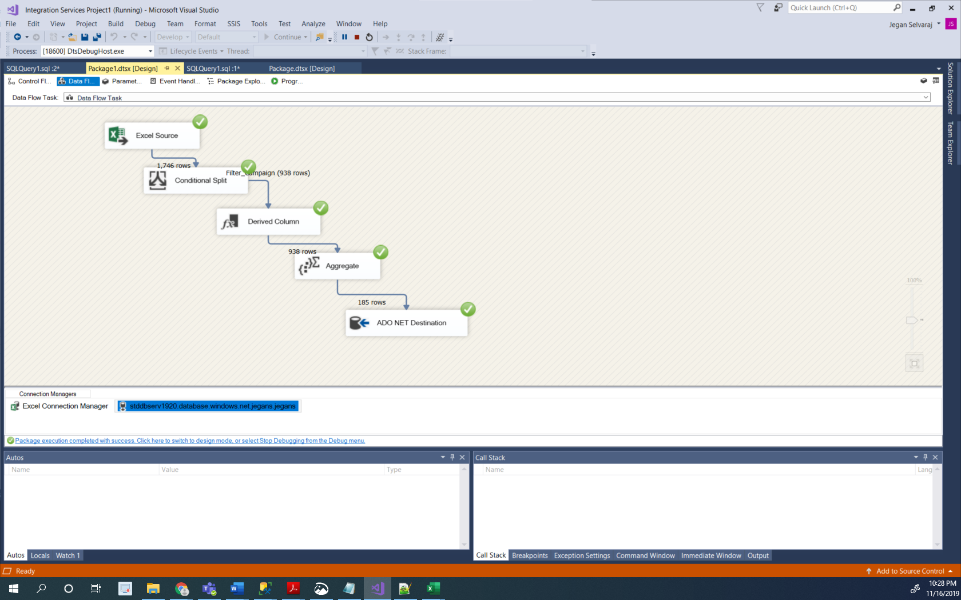

**2)dim_channel**

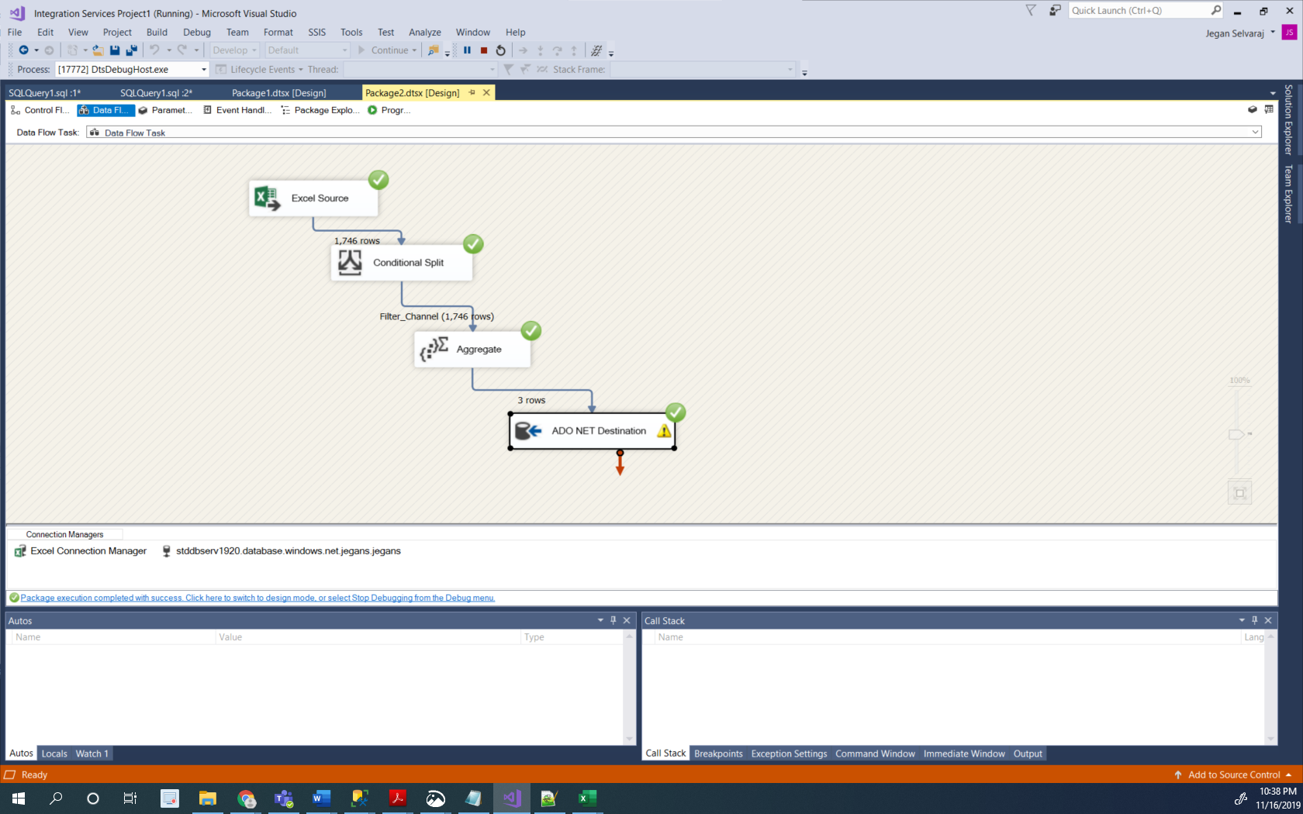

**3)fact_interactions**

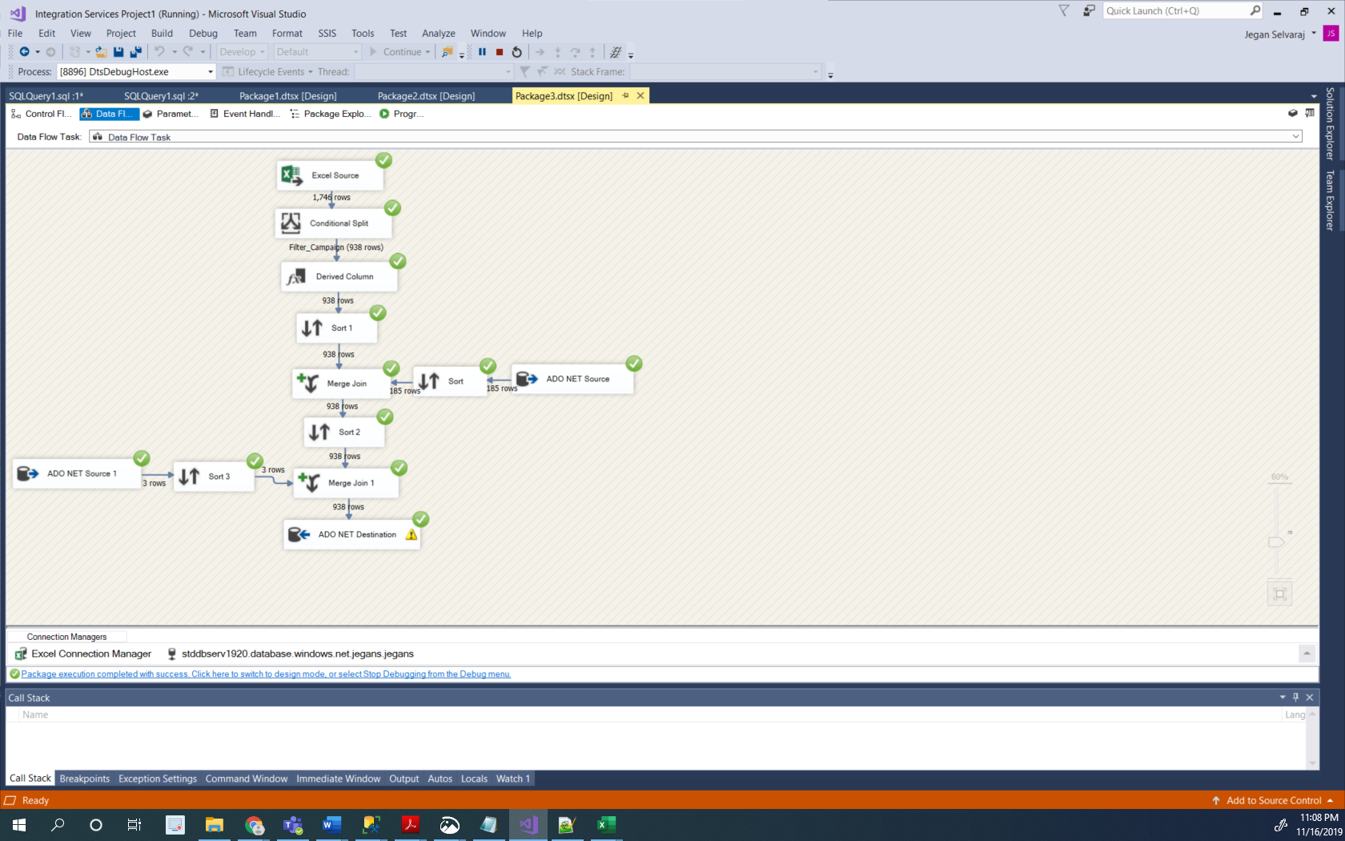

1. Provide total number of row count for each table loaded are as follows

* **dim_count – 185**
* **dim_channel – 3**
* **fact_interactions – 938**

1. Provide partial screen shots of your created and populated tables (dim_time, dim_channel, fact_interactions)
2. **dim_time**

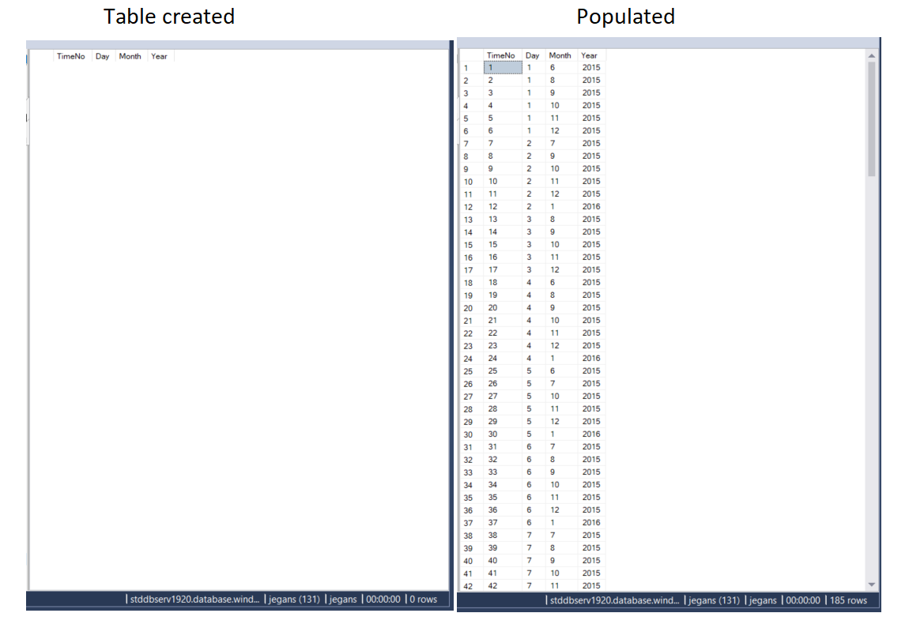

1. **dim_channel**

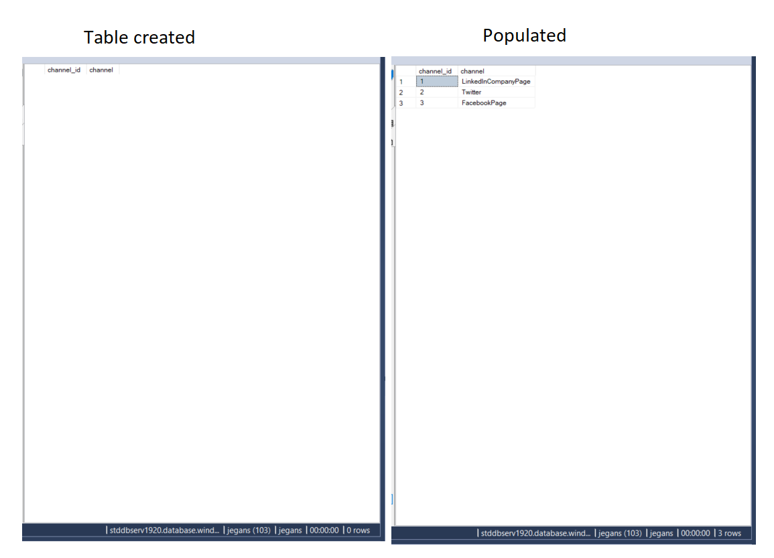

1. **fact_interactions**

